
CC-215-L: Database Systems Lab

Faculty of Computing & Information Technology

BS(IT) Morning - 2025
LAB _03

The objective of this lab is to:
1. Number Functions
2. Date Functions
3. Conversion Functions
4. Character Functions
5. Previous SQL Content
6. REGEXP_LIKE

Course & Lab Instructor: Dr. Asif Sohail
Hope you are fine and feeling yourself comfortable and exciting to play with Structured Query Language (SQL) in this first lab.
You have been taught in the lecture about SQL and query writing. Why not to get all what you have learned with a hands-on experience? So, let’s Start!
Allowed time: 1 hour 10 mins
Note: Do follow these instructions while you are sitting in the lab and performing the tasks.
- Gossips are not allowed. So be gentle and do what you know. The lab is not to deduct your sessional marks but to prepare you to achieve good marks in quizzes, mids and finals and finally have good grades. So, try to perform all your tasks in time and at your own.
- Teacher assistants are for your help, so be nice with them. Respect them as they are teaching you. Raise your hands if you have some problem and need help from TA. Avoid calling them by raising your voice and disturbing the environment of Lab.
- You must revise the content of the past lectures before starting the lab, it will help you resolve most of your general queries and give you the confidence that you can do it.
- Evaluation will be considered final and you cannot debate for the marks. So, focus on performing the tasks when the time is given to you.
- TA may deduct your marks for any kind of ill-discipline or misconduct from your side.
- Finally, pray before you start. And, Best of Luck!

- Kindly paste the query as well as result table screenshot as a result of each task
Sample:
Display All the Employees from emp table
Solution:
Select * from emp
EMPNO | ENAME | JOB | MGR | HIREDATE | SAL | COMM | DEPTNO
7369 | SMITH | CLERK | 7902 | 12/17/1980 | 800 | - | 20
7499 | ALLEN | SALESMAN | 7698 | 02/20/1981 | 1600 | 300 | 30
7521 | WARD | SALESMAN | 7698 | 02/22/1981 | 1250 | 500 | 30
7566 | JONES | MANAGER | 7839 | 04/02/1981 | 2975 | - | 20
7654 | MARTIN | SALESMAN | 7698 | 09/28/1981 | 1250 | 1400 | 30

Task 01: [10 Marks]

- Use a date function to find out first date of current year and the first date of this month. Display each of two in columns with names as ‘1st Date of Year’ and ‘1st Date of Month’.also show day name of both dates

SELECT TO_CHAR(TRUNC(SYSDATE, 'YYYY'), 'DD-MON-YYYY DAY') AS "1st Date of Year",
TO_CHAR(TRUNC(SYSDATE, 'MM'), 'DD-MON-YYYY DAY') AS "1st Date of Month"
FROM dual;

- Find the Salaries which are perfect squares.
select sal from emp where
sqrt(sal)-trunc(sqrt(sal)) = 0 and sal !=0

- Write an SQL query to display the date exactly after half a year and the date exactly after a quarter year from the current system date. The result should be shown in the format: DD-Month-YYYY
SELECT TO_CHAR(ADD_MONTHS(SYSDATE, 6), 'DD-Month-YYYY') AS "After Half Year",
TO_CHAR(ADD_MONTHS(SYSDATE, 3), 'DD-Month-YYYY') AS "After Quarter Year"
FROM dual;

- Display the date on which our next lab is scheduled.

SELECT NEXT_DAY(SYSDATE, 'FRIDAY') AS NEXT_LAB_DATE
FROM DUAL

- Suppose that the employees are hired on a 6-month probation period in the company. Write an SQL query that displays the Employee Name,Job,Starting Date of Probation, Ending date of probation

SELECT ENAME AS EMPLOYEE_NAME,
JOB,
HIREDATE AS STARTING_DATE_OF_PROBATION,
ADD_MONTHS(HIREDATE, 6) AS ENDING_DATE_OF_PROBATION
FROM EMP;

- Find the texts with no numbers in the Tweets table. You must use REGEXP_LIKE
SELECT * FROM TWEETS WHERE REGEXP_LIKE(TEXT,'^[^0-9]*$');

- Write a query to display the ENAME, HIREDATE, and their tenure for those who
were hired in 1980 to 1982.
SELECT ENAME , HIREDATE, EXTRACT(YEAR FROM SYSDATE)-EXTRACT( YEAR FROM HIREDATE) AS TENURE_YEARS FROM EMP WHERE EXTRACT( YEAR FROM HIREDATE) BETWEEN 1980 AND 1982;

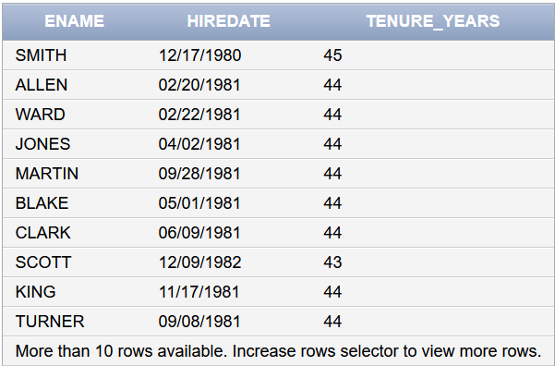

- Show employees who were hired in the first quarter (Jan–Mar) of any year, along with their hire month in words.
SELECT ename,
hiredate,
TO_CHAR(hiredate, 'Month') AS "Hire Month"
FROM emp
WHERE TO_CHAR(hiredate,'MM') BETWEEN 1 AND 3;

- Create a Salary Bar (Histogram) as shown. You can use the “█” symbol to create the chart. One █ = 800.

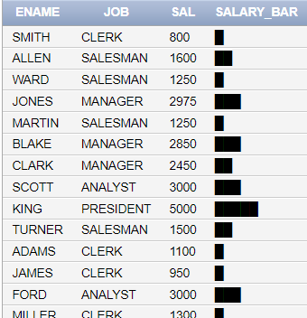

SELECT ENAME,JOB,
SAL,
RPAD(' ', SAL/800+1, '█') AS SALARY_BAR
FROM EMP;

- List the salary of the employee in the following format: (Salary: ‘$99,999’)
select ename, to_char(sal,'$9,999') as "Formatted Salary" from emp

Task 02: [20 Marks]

- Display employees hired in leap year.
SELECT ename, hiredate
FROM emp
WHERE MOD(TO_CHAR(hiredate, 'YYYY'), 4) = 0
AND (MOD(TO_CHAR(hiredate, 'YYYY'), 100) != 0
OR MOD(TO_CHAR(hiredate, 'YYYY'), 400) = 0);

- Find how many seconds have passed since your admission in this prestigious IT institute (start from 1st September ,2024)
select TO_NUMBER(SYSDATE-TO_DATE('01-11-2024','DD-MM-YYYY'))*24*60*60 AS SECS_PASSED FROM DUAL;

- Write a query to find the text from TWEETS containing a URL. (Must use Regular Expressions)
URL format: https://www.{1 or more characters}.com

SELECT * FROM TWEETS WHERE REGEXP_LIKE(TEXT,'https://www.[A-Za-z].*.com');

- Show Employee Name and Salary Rounded to Nearest 10.
SELECT ename AS "Employee",
ROUND(sal, -1) AS "Rounded Salary"
FROM emp;

- Suppose that all the employees are hired on 6 months’ probation period. Write a query
to display ename, hiredate, confirmation date, sal, and comm. Display ‘Y/N’
if the comm of an employees is NULL.
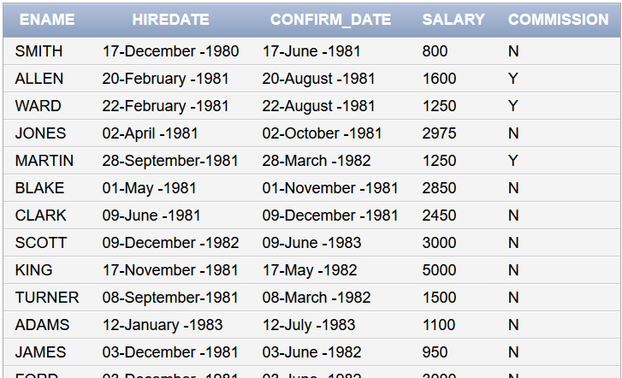

SELECT ENAME,TO_CHAR(HIREDATE,'DD-Month-YYYY')AS HIREDATE,TO_CHAR(ADD_MONTHS(HIREDATE,6),'DD-Month-YYYY') AS CONFIRM_DATE,SAL AS SALARY,

TRANSLATE(TO_CHAR(SIGN(NVL(COMM,0))),'01','NY')

AS COMMISSION FROM EMP

- Write a query to find employees whose names contain exactly 4 characters.
SELECT ename
FROM emp
WHERE REGEXP_LIKE(ename, '^[A-Za-z]{4}$');

- Write an SQL query to retrieve the salaries that contain exactly three digits, where the sum of the digits of the salary, each raised to the power of three, is greater than 1000.

SELECT SAL, POWER(SUBSTR(TO_CHAR(SAL),1,1),3) + POWER(SUBSTR(TO_CHAR(SAL),2,1),3) + POWER(SUBSTR(TO_CHAR(SAL),3,1),3) AS SUM FROM EMP WHERE

- Display ENAME, SAL, and the number of salary increments required to double the current salary if the increment is 5% yearly. Use this formula to find increments.
$$n≥\frac{ln(1.05)}{\begin{aligned}ln\left(2\right) \\ \end{aligned}}$$

SELECT ENAME,
SAL,
CEIL( LOG(10, 2) / LOG(10, 1.05) ) AS INCREMENTS_REQUIRED
FROM EMP;

- Write a query that displays the employee’s names with the first letter capitalized
and all other letters lowercase, and the length of the names, for those employees
whose names start with J,K, OR S (Both capital and small). Give each column an
appropriate name. Use regexp_like in your query

SELECT
INITCAP(ename) AS "Formatted Name",
LENGTH(ename) AS "Name Length"
FROM emp
WHERE REGEXP_LIKE(ename, '^[JjKkSs]');

- Find tweets containing ipv4 adresses.

SELECT text
FROM tweets
WHERE REGEXP_LIKE(text, '([0-9]{1,3}\.){3}[0-9]{1,3}');

Task 03: [15 Marks]
Question 01: We need to store data in a matrix like this for every employee where each element is a scalar.
[[A] [B] [C]
[D] [E] [F]
[G] [H] [I]]
Where:
- A → 1st letter of ENAME
- B → Last letter of ENAME
- C → Length of ENAME
- D → 2-digit hire year (YY)
- E → Month of hire padded to 2 digits
- F → Day of hire padded to 2 digits
- G → DEPTNO divided by 10
- H → Number of vowels.
- I → (SAL modulo 9)
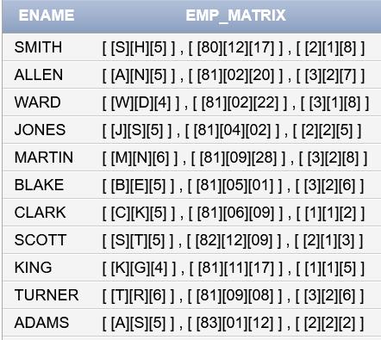

Sol 1 :
SELECT
ENAME,
'[ ' || '[' || SUBSTR(ENAME,1,1) || '][' || SUBSTR(ENAME,-1,1) || '][' || LENGTH(ENAME) || ']' || ' ] , ' ||
'[ ' || '[' || TO_CHAR(HIREDATE,'YY') || '][' || TO_CHAR(HIREDATE,'MM') || '][' || TO_CHAR(HIREDATE,'DD') || ']' || ' ] , ' ||
'[ ' || '[' || DEPTNO/10 || '][' ||
to_char(length(ename)-length(replace( replace ( replace ( replace ( replace( lower(ename),'a','' ),'e',''),'i',''),'o',''),'u',''))) || '][' ||
MOD(SAL,9) || ']' || ' ]' AS EMP_MATRIX
FROM EMP;

Sol 2 :
SELECT
ENAME,
'[ ' || '[' || SUBSTR(ENAME,1,1) || '][' || SUBSTR(ENAME,-1,1) || '][' || LENGTH(ENAME) || ']' || ' ] , ' ||
'[ ' || '[' || TO_CHAR(HIREDATE,'YY') || '][' || TO_CHAR(HIREDATE,'MM') || '][' || TO_CHAR(HIREDATE,'DD') || ']' || ' ] , ' ||
'[ ' || '[' || DEPTNO/10 || '][' ||
LENGTH(REGEXP_REPLACE(LOWER(ENAME),'[^aeiou]')) || '][' ||
MOD(SAL,9) || ']' || ' ]' AS EMP_MATRIX
FROM EMP;

Question 02: Employee monthly salary projection for each employee, calculate a complex salary score. Use this formula:
SELECT
ENAME,
SAL,
ROUND(
(
TANH(SAL/3000) +
SIN(SAL/200) * COS(SAL/150) +
1 / (1 + EXP(-0.01 * (SAL-3000))) +
MOD(SAL,7)/10 +
SQRT(SAL)/100
) / 5,
4
) AS COMPLEX_SALARY_SCORE
FROM EMP;

Question 03: Write an SQL query to display the employee name, salary, and a visual representation of their salary using asterisks (*).
Each asterisk should represent one thousand in the salary, such that:
Salaries less than 1000 are shown with 1 asterisk (*)
Salaries from 1000 to 1999 are shown with 2 asterisks (**)
Salaries from 2000 to 2999 are shown with 3 asterisks (***), and so on.

SELECT ename , sal,
RPAD('*', CEIL(sal/1000), '*') AS "Stars"
FROM emp;

Task 04: VIVA QUESTIONS [5 Marks]

